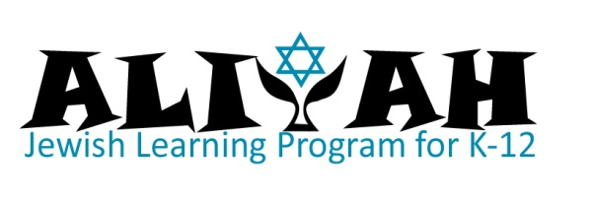
Online Registration Information

Shalom! Welcome to Neveh Shalom’s ALIYAH Jewish learning program!

This is your guide to our ONLINE registration process. Please don’t hesitate to give us a call if you need any assistance.

GETTING STARTED:
Go to http://www.nevehshalom.org/ and click “Member Login” (upper right corner).
- If you don’t know your User ID and password, click “Forgot your User ID or password?” and it will be automatically emailed to you. If this fails, call the CNS office at 503-246-8831.
- If you are not a member of Neveh Shalom, please contact Daniela Meltzer, 503-293-7305 or programs@nevehshalom.org.
Before you begin registration, please “Update Member Information” (left column). Please update Adult 1, Adult 2, Address, and Child Information (including Hebrew name). It is crucial that we have your correct contact information, including email & cell phones.

EMERGENCY INFORMATION:
Once member info is updated, under “Register for classes,” click the subcategory for your child’s grade level (left column).
Select the child’s name and click “Registration”
Click “OK” to review the emergency info for your child. Click “Save” at the end of each section.
REGISTRATION:
Once Emergency Info is updated you must AGAIN click the subcategory under “register for classes” (left column) to enroll your child.

SELECTING MORE THAN ONE OPTION: To help you save time on registration, we have bundled options such as
- ALIYAH PLUS dinner
- 5th Grade PLUS bar mitzvah tutoring
Each time you submit a registration you will have the option of paying or adding another registration to your “cart”. If you are enrolling more than one child, you will need to repeat the registration process.
PAYMENT:
Fees: It pays to be early! Register by June 30, 2017
and receive earlybird pricing, a $75 savings for each child’s registration. Regular registration continues until August 15. Registration AFTER August 15 requires an additional $75 administrative fee.

Payment Policy: A deposit is required to complete registration. The balance may be paid in full, or in monthly installments. All installment payments are required to arrange “auto-pay” using a credit card or auto-withdrawal from a checking account. Checks are only accepted for full-year payments.

Registration for 2017-18 education programs requires 2016-17 CNS accounts be current. Please contact Debbi Villani-Allen to make payments, or Daniela Meltzer to discuss a payment plan for current balances owed.

Educational fees for the year are non-refundable. Your commitment to these fees, whether paid in full or by installments, is accepted at time of registration.

Financial aid requests must be submitted during the EARLYBIRD registration period (closes on June 30).
At the bottom of the registration page on a tab labeled “The balance will be billed,” you have the choice between “# installments…” or “Request Financial Aid.” To request financial aid or make alternative payment arrangements, you must still make a deposit. Contact us for a financial aid form.

SPECIAL NEEDS, ALLERGIES, & MEDICATIONS
Please fill out a separate online form to list your child’s special needs, allergies and medications.

