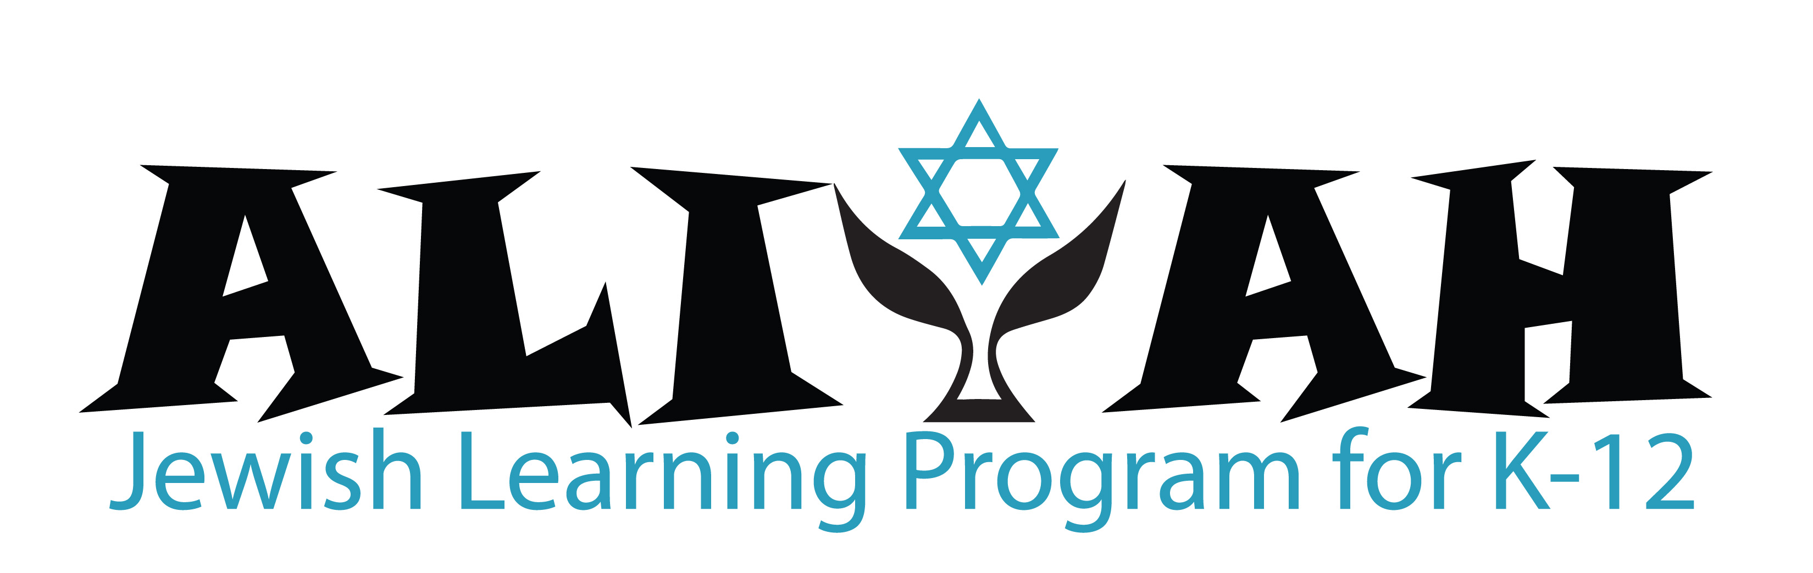
K-6 Curriculum: Kindergarten-2nd Grades
 | With Hebrew Tutors  30 minute private tutoring sessions weekly.  Individualized goals based on grade level and capability. |  | Sunday in ALIYAH  3 hour program  Judaics – Specials – Tefilah
 | Ivrit – Hebrew | Tefilah – Prayer | Yahadut – Judaics | Specials & Tefilah
K | Introduction to alef-bet and vowels: songs, sounds, & activities  Group learning option! | Shabbat blessings (candles, challah, wine/juice)  Shema Yisrael  Oseh Shalom  Ma Tovu | Shabbat & Holidays  What’s special about being Jewish?  Creating a Shabbat Box  Mitzvah: Ahavat Yisrael  (Loving the People of Israel) | Music & Dance  Holidays & Seasonal themes  Library -Stories  by Grade  Tefilah Prayer Practice with K-2 Community:  Ma Tovu  Morning blessings  Barchu – Yotzer Or  Shema V’ahavta  Amidah  Oseh Shalom  Theological themes: Gratitude  Wonder  The meaning of Am Yisrael
1 | Pre-reading skills: alef bet, vowels,  putting letters & sounds together, writing letters | Torah songs  Shema, Baruch  Barchu call and response | Beit Kneset (Synagogue)  The 5 books of Torah  Creating our own Torah  Learning our Hebrew names  Mitzvah: Hiddur Mitzvah  (Beautifying a mitzvah)
2 | Alef-bet decoding:  advanced letter recognition,  reading & writing practice | Shema, V’ahavta  Barchu & Yotzer Or  1st line of Amidah | Avot & Imahot: our ancestors and role models in America and Israel, Sharing our family trees & family stories  Mitzvah: Kibud Av v’Em  (Honoring our parents and ancestors)
K-6 Curriculum: 3rd-5th Grades
 | With Hebrew Tutors  30 minute private tutoring sessions weekly.  Individualized goals based on grade level and capability. |  | Sunday in ALIYAH  3 hour program  Judaics – Specials – Tefilah
 | Ivrit – Hebrew | Tefilah – Prayer | Yahadut – Judaics | Chugim (Electives) & Tefilah
3 | Reading proficiency; understanding Hebrew roots; expanding modern and prayer vocabulary | V’ahavta  Ein Keloheinu  Ahavat Olam | Jewish traditions through the year and around the world:  Diversity of Jewish people and practices  Mitzvah: Hachnasat Orchim  (Welcoming Strangers or Guests) | Each Semester, Choice of:  Art  History-Super Hero  TBD  Tefilah Prayer Practice with 3rd-6th Gr Community:  Ma Tovu  Barchu  Shema-V’ahavta  Amidah  Prayer for Healing  Kaddish  Oseh Shalom  Theological themes:  Individual & community  Tradition & change  Music & Dance:  Holidays & Seasonal themes
4 | Increasing reading fluency;  integration of modern and prayer Hebrew, basic Hebrew grammar | Adon Olam  Shalom Aleichem  Kedusha Responses | Jewish Values: taking care of ourselves, each other, and the world, active mitzvah projects  Mitzvah: Bikur Cholim/Refuat HaNefesh, Refuat Haguf  (Visiting and praying for those who need healing of body/mind)
5 | Increasing reading fluency;  integration of modern and prayer Hebrew, basic Hebrew grammar | Aleinu  V’Shamru  L’cha dodi | Jewish Lifecycle Rituals for  birth, naming, bnai mitzvah, conversion, marriage, divorce, and death  Mitzvah: Piku'ach Nefesh  (The value of Human Life)
K-6 Curriculum: 6th Grade

 | With Hebrew Tutors  30 minute private tutoring sessions weekly.  Individualized goals based on grade level and capability. | Sunday in ALIYAH  3 hour program  Judaics – Specials – Tefilah
6 | Advanced tefilah practice and concepts  Torah Service: all individual and communal blessings for taking out and returning the Torah.  Review of all earlier prayers. | - Leadership in its many forms: ritual, social, communal, personal, and political.  - Preparing for the rite of passage of bar/bat/brit mitzvah.  - Family programs on sacred time, mitzvah projects, Chanukah/Jewish identity, and preparing a dvar Torah.  - Demystifying texts from Torah and Talmud  - Leading Chanukah, Purim, & Lag Ba’Omer programs for K-5  Mitzvah: Tzedakah – acting with justice  Tefilah:  Ma Tovu, Barchu, Shema-V’ahavta, Amidah  Prayer for Healing, Kaddish, Oseh Shalom  Torah Service: Taking out and returning the Torah  Leading tefilah with voice, choreography, poise  Theological themes:  Individual & community  Tradition & change  Finding our spiritual touchpoints

